|  |  |  |
| --- | --- | --- |
| **Chapter**  **No** | **Title** | **Page**  **No** |
|  | **Synopsis** | **1** |
| **1** | **Introduction** | **3** |
| **2** | **System Requirement and Specification**  **2.1 Hardware Requirement**  **2.2 Software Requirement** | **5** |
| **3** | **Visual Basic 6.0** | **7** |
| **4** | **SQL Server**  **4.1 SQL Server Management Studio** | **10** |
| **5** | **System Design**  **5.1 DataFlow Diagram**  **5.2 Entity Relationship Diagram**  **5.3 DataBase Design** | **13**  **14**  **15** |
| **6** | **Screenshots** | **17** |
| **7** | **Testing** | **24** |
| **8** | **Conclusion** | **27** |
| **9** | **Bibliography** | **29** |
| **10** | **Coding** | **31** |

**TABLE OF CONTENTS**

**List of Figures**

|  |  |  |
| --- | --- | --- |
| **Figure No.** | **Title** | **Page No.** |
| **6.1** | **Splash Screen** | **17** |
| **6.2** | **Login Page** | **17** |
| **6.3** | **Main Form** | **18** |
| **6.4** | **Form to Change Password** | **18** |
| **6.5** | **Form to Add New User** | **18** |
| **6.6** | **Form to Delete User** | **19** |
| **6.7** | **Categories Form** | **19** |
| **6.8** | **Item Information Form** | **19** |
| **6.9** | **Table Information Form** | **19** |
| **6.10** | **Order Information Form** | **20** |
| **6.11** | **Bill Generation Form** | **20** |
| **6.12** | **Monthly Collection Form** | **20** |
| **6.13** | **Consumption Bill Report** | **21** |
| **6.14** | **Today’s Collection Report** | **21** |
| **6.15** | **Monthly Collection Report** | **21** |
| **6.16** | **All Customer Order Report** | **21** |
| **6.17** | **Menu Report** | **22** |

**SYNOPSIS**

**SYNOPSIS**

Now a days we can see many restaurants are established which serves ready-made-food. All the activities such as food item list, menus, tables with different rents, customers ‘orders, daily collection reports., etc everything done in the manual system.

Then the biggest problem arises whenever many customer places the order at the same time with varieties of food items in different tables becomes difficult for the employees to handle the customers ‘orders. Whenever they want to alter their menu, it is also a challenge for them to do. But with the computerized system all this problem can be resolved in seconds.

**RESTAUARANT MANAGEMENT SYSTEM** is a desktop application. This system is developed to automate the day-to-day activities of a restaurant. This system can be used by the employees to handle the customers and their orders. It makes the easier way to generate accurate reports.

Scope of project in building a computerized system for silk route to handle billing restaurant records was to include the employees who are involved in the process of billing of a customer to storage of restaurant records and enables to view the records as desired. The employees are given limited access in order to safe guard the privacy and security of the records. The database is maintained in the whole project

**INTRODUCTION**

**CHAPTER 1**

**INTRODUCTION**

**Restaurant Management system:**

**Restaurant management** system is the system for managing the restaurant business. Restaurant management can vary across multiple management styles, however, there is always one common denominator when it comes to setting goals: maximizing a restaurant’s profitability. In order to maximize a restaurant’s profitability, one has to always examine and understand a restaurant’s

operational costs and how these relate to a restaurant’s productivity and efficiency in delivering quality service to its customers. Management takes a very important role in controlling and manipulating the balance of costs and profitability.

An effective manager must always concern himself/herself with restaurant issues that pertain to including items, categories, pricing, order-taking, and much more. Oftentimes, a restaurant’s profitability either rises or falls depending on how well it is being managed.

Managing a restaurant using a well-developed software minimizes the liabilities of mismanagement and productivity. The incorporation of a Restaurant Management Software in the managing of various business processes entails that

your restaurant is competitive, innovative, well-managed, and up-to-date with the latest management and business trends.

This restaurant management system can be used by employees in a restaurant to handle the clients, their orders and can help them easily find tables.

The restaurant menu is organized by categories (south-Indian meal,

soups, salads, Chinese dish, sides and drinks) of menu items. Each menu item has a name, price. It’s easy to present the reports of the day- to- day activities.

**SPECIFICATION REQUIREMENTS**

+

**CHAPTER 2**

**SPECIFICATION REQUIREMENTS**

To be used efficiently, all computer software needs certain hardware components or the other software resources to be present on a computer. These pre-requisites are known as(computer) system requirements and are often used as a guideline as opposed to an absolute rule.

**2.1. HARDWARE REQUIREMENTS:** The most common set of requirements defined by any operating system or software application is the physical computer resources, also known as hardware. A hardware requirements list is often accompanied by a hardware compatibility list (HCL), especially in case of operating systems. An HCL lists tested, compatibility and sometimes incompatible hardware devices for a particular operating system or application. The following sub-sections discuss the various aspects of hardware requirements.

**HARDWARE REQUIREMENTS FOR PRESENT PROJECT**:

PROCESSOR : Intel Pentium 3 or above

RAM : 1GB or above

HARD DISK : 128 GB or above

MONITOR : Standard colour monitor

KEYBOARD : Standard keyboard

**2.2. SOFTWARE REQUIREMENTS:** Software Requirements deal with defining software resource requirements and pre-requisites that need to be installed on a computer to provide optimal functioning of an application. These requirements or pre-requisites are generally not included in the software installation package and need to be installed separately before the software is installed

**SOFTWARE REQUIREMENTS FOR PRESENT PROJECT:**

OPERATING SYSTEM : WINDOWS 10

FRONT END : VISUAL BASICS 6.0

BACK END : SQL SERVER

**Visual Basics 6**

**CHAPTER 3**

**VISUAL BASIC 6.0**

**Visual basic** is an ideal program language, for developing sophisticated business application. It makes use of graphical interface for the creation of robust and powerful application. The GUI as the name suggests, uses illustrations for the text which enables its user to interact with the application. This feature makes it easier to comprehend the things in a quicker and easier way

Coding in a GUI environment is quite a transition to traditional – linear programming methods, where the user is guided through path of execution and is limited to a small set of operation. The number of options that are open to the user and developer features such as easier comprehension, user friendliness, faster access and many such other features make it an interesting tool to work with.

So what is Visual basic? The Visual path refers to the method used to create the Graphical User Interface (GUI). Rather than writing numerous lines of codes to describe the appearance and location of interface elements, you simply add pre-built objects into place on screen.

The “Basic” part refers to the BASIC (Beginners all-purpose symbolic instruction code) language a language used by more programmers rather than any other language in the history of computing. Visual basic has evolved from the original Basic language and now contains several hundred statements, functions and keywords many of which relate directly to the windows GUI. Whether your goal is to create a small utility for yourself or your work group, a large enterprise-wide system, or event distributed applications spanning the globe via Internet, Visual basic has the tools you need.

Data access features allow you to create databases, front-end applications and scalable sever side components for most popular database formats, including command prompt sever and other enterprise level database. ActiveX technologies allow you to use the functionally provided by the other applications, such as Microsoft word processor, Microsoft Excel spreadsheet, and other windows application. You can even automate application and objects created using the professional or Enterprise editions of visual basic.

This “Basic” part refers to the BASIC (Beginners All-purpose Symbolic Instruction code) language a language used by more programmers rather than any other language in the history of computing. Visual Basic has evolved from the original Basic language and now contains several hundred statements, functions and keywords many of which relate directly to the windows GUI. Whether your goal is to create a small utility for yourself or your work group, a large enterprise-wide system, or even distributed applications spanning the globe via Internet, Visual Basic has the tools you need. Data access features allow you to create database, front-end applications and scalable server-side components of most popular database formats, including Microsoft Access server side and other enterprise level database.

This chapter introduces the essential components of the visual basic language. After creating the interface to your application using forms and controls, you need to write the code that defines the application behavior. As with any programming language, Visual basic supports a number of common programming constructs and languages elements. Visual basic is an object oriented based programming language. The mere mention of objects may cause undue anxiety in many programmers. In this programming language you are dealing with objects and their handling. Once you understand a few basic concepts, object actually help to make programming easier than ever before.

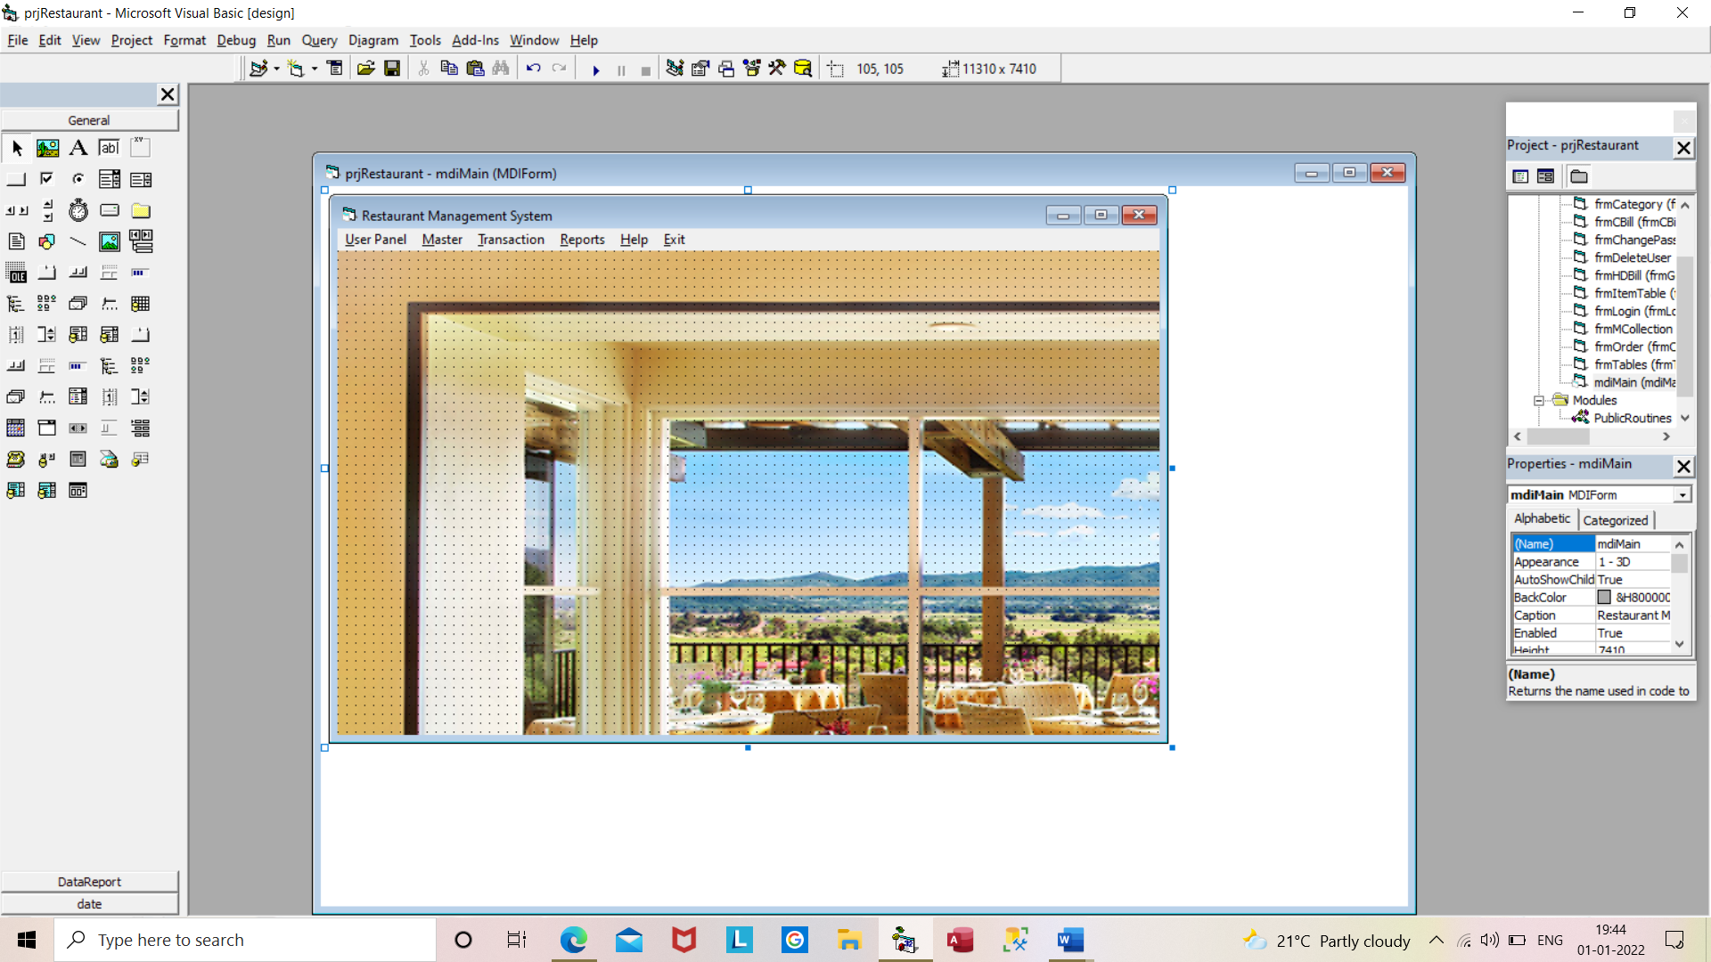

**SQL SERVER**

**CHAPTER 4**

**SQL SERVER**

SQL Server is a database server by Microsoft. The Microsoft relational database management system is a software product which primarily stores and retrieves data requested by other applications. These applications may run on the same or a different computer.

SQL is **a specialized language for updating, deleting, and requesting information from databases**. SQL is an ANSI and ISO standard, and is the de facto standard database query language.

SQLCMD is a command line application that comes with Microsoft SQL Server, and exposes the management features of SQL Server. It allows SQL queries to be written and executed from the command prompt. It can also act as a [scripting language](https://en.wikipedia.org/wiki/Scripting_language) to create and run a set of SQL statements as a script. Such scripts are stored as a sqlfile, and are used either for management of databases or to create the database schema during the deployment of a database.

SQLCMD was introduced with SQL Server 2005 and has continued through SQL Server versions 2008, 2008 R2, 2012, 2014, 2016 and 2019. Its predecessor for earlier versions was OSQL and ISQL, which were functionally equivalent as it pertains to TSQL execution, and many of the command line parameters are identical, although SQLCMD adds extra versatility.

[**4.1 SQL Server Management Studio**](https://en.wikipedia.org/wiki/SQL_Server_Management_Studio)

[SQL Server Management Studio](https://en.wikipedia.org/wiki/SQL_Server_Management_Studio) is a [GUI](https://en.wikipedia.org/wiki/GUI) tool included with SQL Server 2005 and later for configuring, managing, and administering all components within Microsoft SQL Server. The tool includes both script editors and graphical tools that work with objects and features of the server. SQL Server Management Studio replaces [Enterprise Manager](https://en.wikipedia.org/w/index.php?title=Enterprise_Manager&action=edit&redlink=1) as the primary management interface for Microsoft SQL Server since SQL Server 2005. A version of SQL Server Management Studio is also available for SQL Server Express Edition, for which it is known as *SQL Server Management Studio Express* (SSMSE).

A central feature of SQL Server Management Studio is the Object Explorer, which allows the user to browse, select, and act upon any of the objects within the server. It can be used to visually observe and analyse query plans and optimize the database performance, among others. SQL Server Management Studio can also be used to create a new database, alter any existing database schema by adding or modifying tables and indexes, or analyse , performance . It includes the query windows which provide a GUI based interface to write and execute queries.

Use it to deploy, monitor, and upgrade the data-tier components used by your applications, as well as build queries and scripts. Microsoft SQL Server belongs to "Databases" category of the tech stack, while Microsoft SQL Server Management Studio can be primarily classified under "Database Tools".

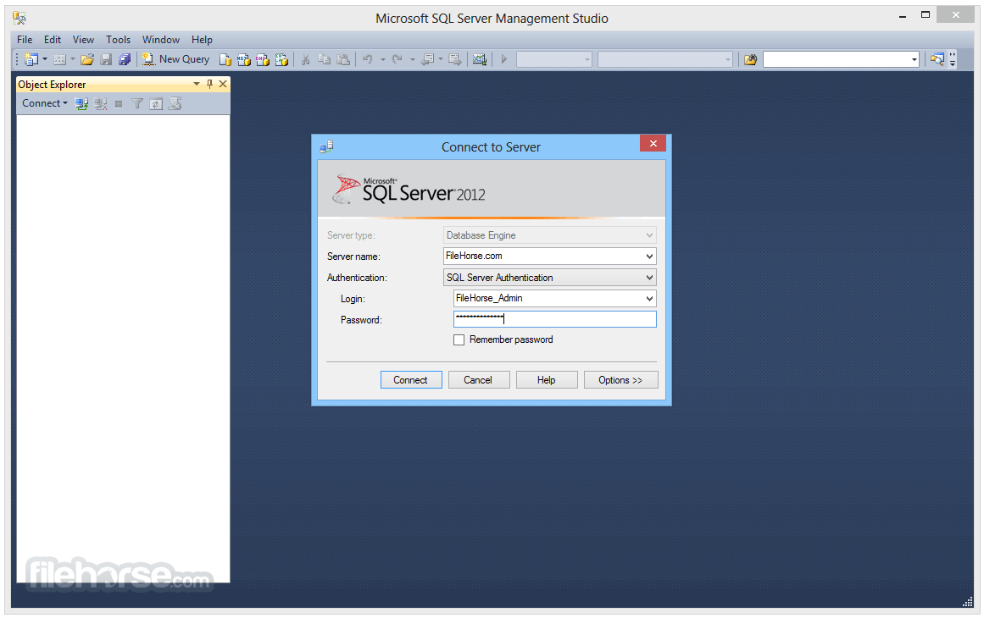

SQL Server Management Studio will help you to connect with four different Server Types

1. Database Engine: To work with relational databases. Here, we use the Transact [SQL](https://www.tutorialgateway.org/sql/) queries to communicate with the server.
2. Analysis Services: This is to work with [SQL Server Analysis Services](https://www.tutorialgateway.org/ssas/) (SSAS).
3. Reporting Services: This Server type is to work with [SQL Server Reporting Services](https://www.tutorialgateway.org/ssrs/) (SSRS).
4. Integration Services: This Server type is to work with [SQL Server Integration Services](https://www.tutorialgateway.org/ssis/) (SSIS).

**SYSTEM DESIGN**

**CHAPTER 5**

**SYSTEM DESIGN**

**5.1 Data Flow Diagram (DFD)**

Data flow diagram is a graphical representation of data movement, process files used in support of an information system. Unlike detail flow charts, DFDs do not supply detailed description of modules but graphically describe a system’s data and how the data interact with the system. A data flow diagram represents the information at each processing points in the system and the direction it takes from the source and destination. To construct a data flow diagram, we use

* Arrows
* Circles
* Open-ended boxes
* Squares

An arrow identifies data flow or data in motion. Circle stands for a process that converts data into information. An open-ended box represents a data source or a temporary repository of data. A square defines a source or the destination of given data

The following information rules govern construction of DFD

* Arrows should not cross each other
* Squares, circles, and files must bear names

**DATA FLOW DIAGRAM**

**FOR**

**RESTAURANT MANAGEMENT SYSTE**

Staff

**USER**

**DATABASE**

**Level 0 DFD**

**5.2 ER Diagram**

**ER Diagram**

**For**

**Restaurant Management System**

USER LOGIN

CUSTOMER

**MANAGES**

**ORDER**

**PLACES**

REPORT

**HAS**

**CATEGORY**

**TABLE**

**ITEMS**

**5.3 DATABASE DESIGN**

|  |  |
| --- | --- |
| **Data Field** | **Data Types** |
| User_name | nvarchar(50) |
| Password | nvarchar(50) |

**Login Table Tables Table**

|  |  |
| --- | --- |
| **Data Field** | **Data Types** |
| Table_No | Int |
| Rent | Int |

|  |  |
| --- | --- |
| **Data Field** | **Data Types** |
| C_No | int |
| C_Name | nvarchar(50) |

**Category Table Customer Table**

|  |  |
| --- | --- |
| **Data Field** | **Data Types** |
| Cat_Id | int |
| Cat_Name | nvarchar(30) |

**Item Table Order Table**

|  |  |
| --- | --- |
| **Data Field** | **Data Types** |
| Item_Name | nvarchar(50) |
| Rate | int |
| Cat_Id | int |

|  |  |
| --- | --- |
| **Data Field** | **Data Types** |
| O_NO | Int |
| O_Date | Date |
| C_Name | nvarchar(50 |
| Amount | Int |
| Discount | Int |
| BAmount | Int |

|  |  |
| --- | --- |
| **Data Field** | **Data Types** |
| O_NO | int |
| O_Date | Date |
| C_Name | nvarchar(50) |
| O_Table | int |
| Item_Name | nvarchar(50) |
| Qty | int |
| Rate | int |
| ItemAmount | int |
| Amount | int |
| Discount | int |
| BAmount | int |

**Order Item Table**

**SCREENSHOTS**

**CHAPTER 6**

**Screenshots**

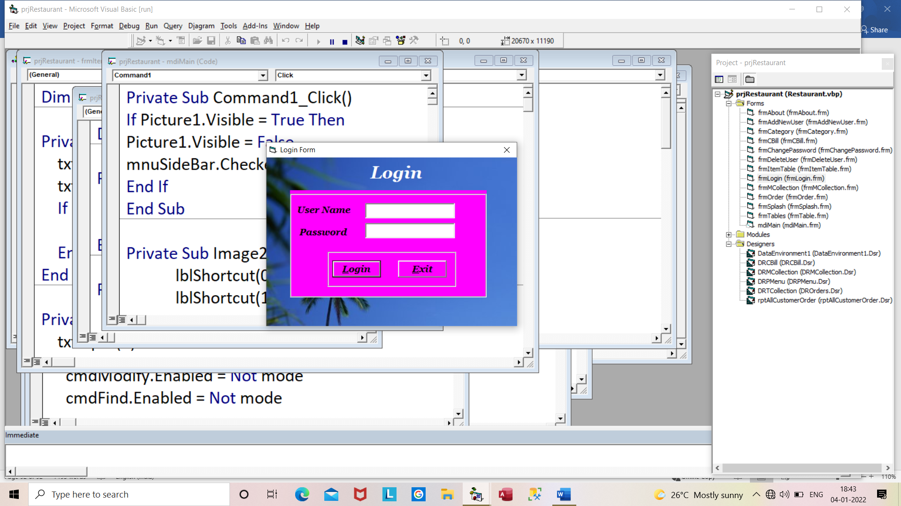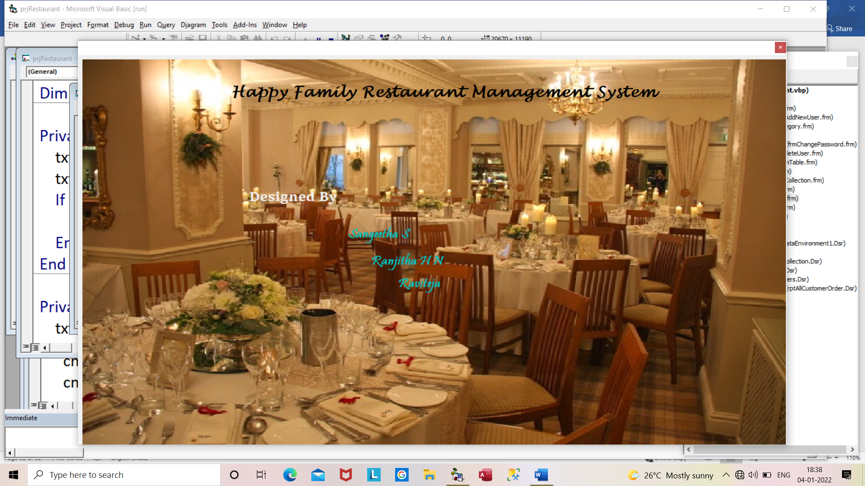

**Fig 6.1: Splash Screen**

**Fig6.2: Login Page**

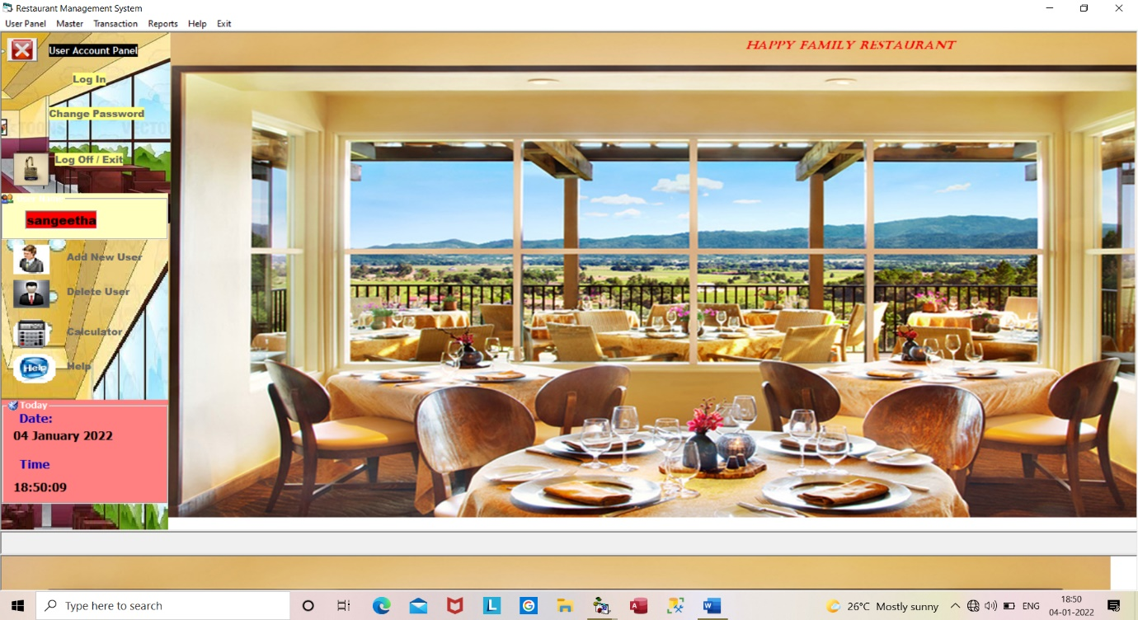

**Fig 6.3: Main Form**

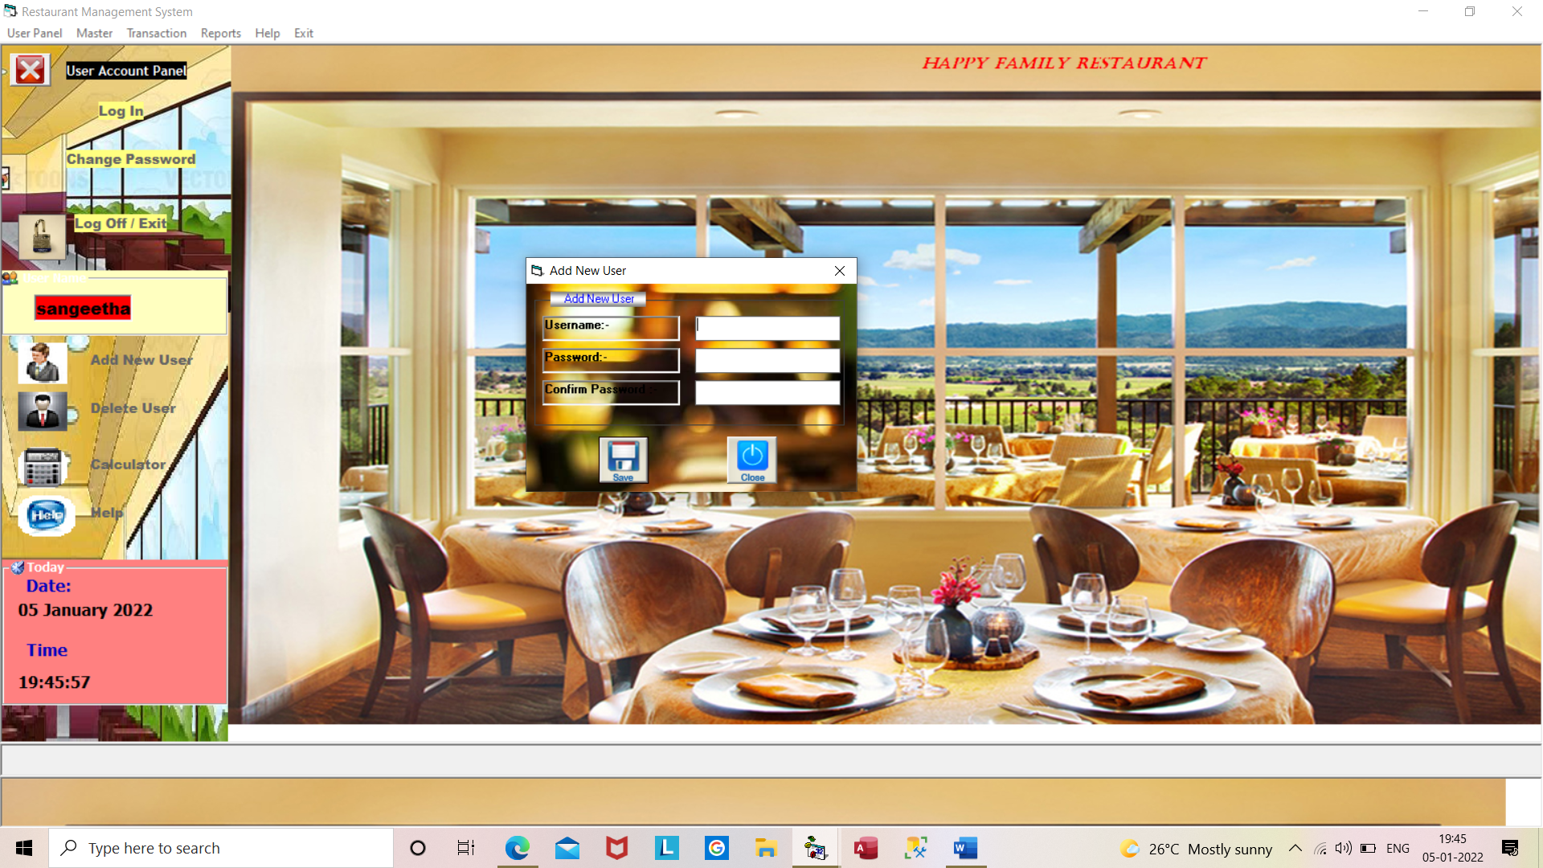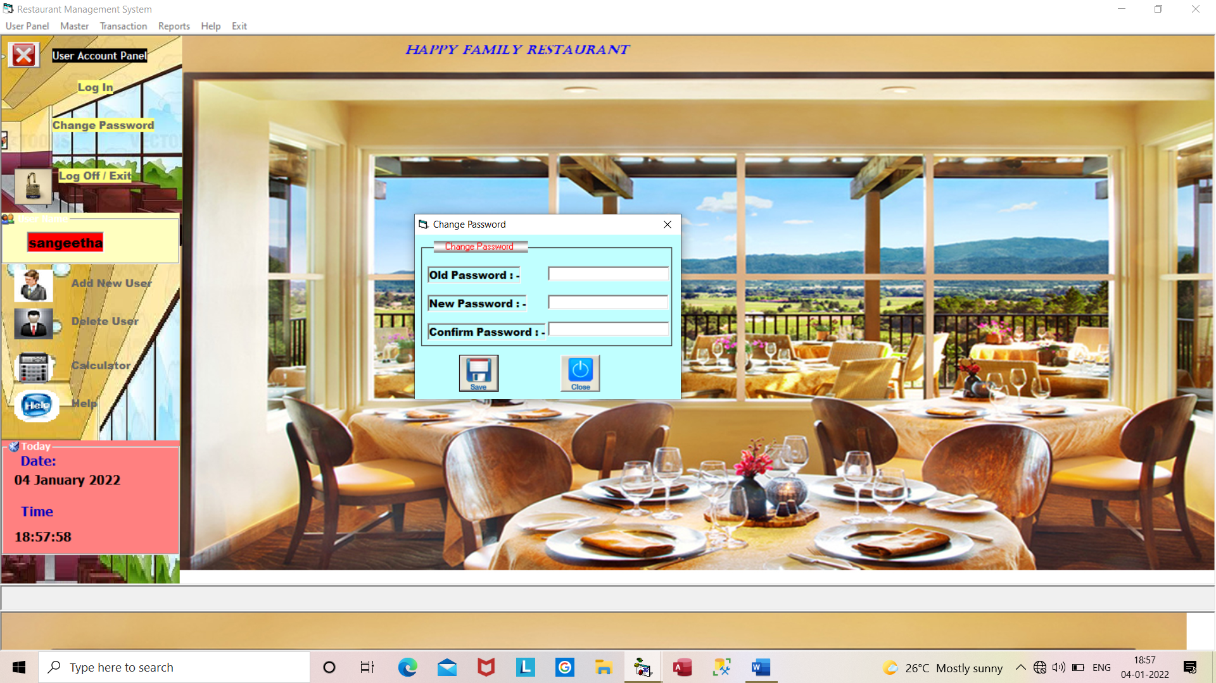

**Fig 6.4: Form to Change Password Fig 6.5: Form to Add New User**

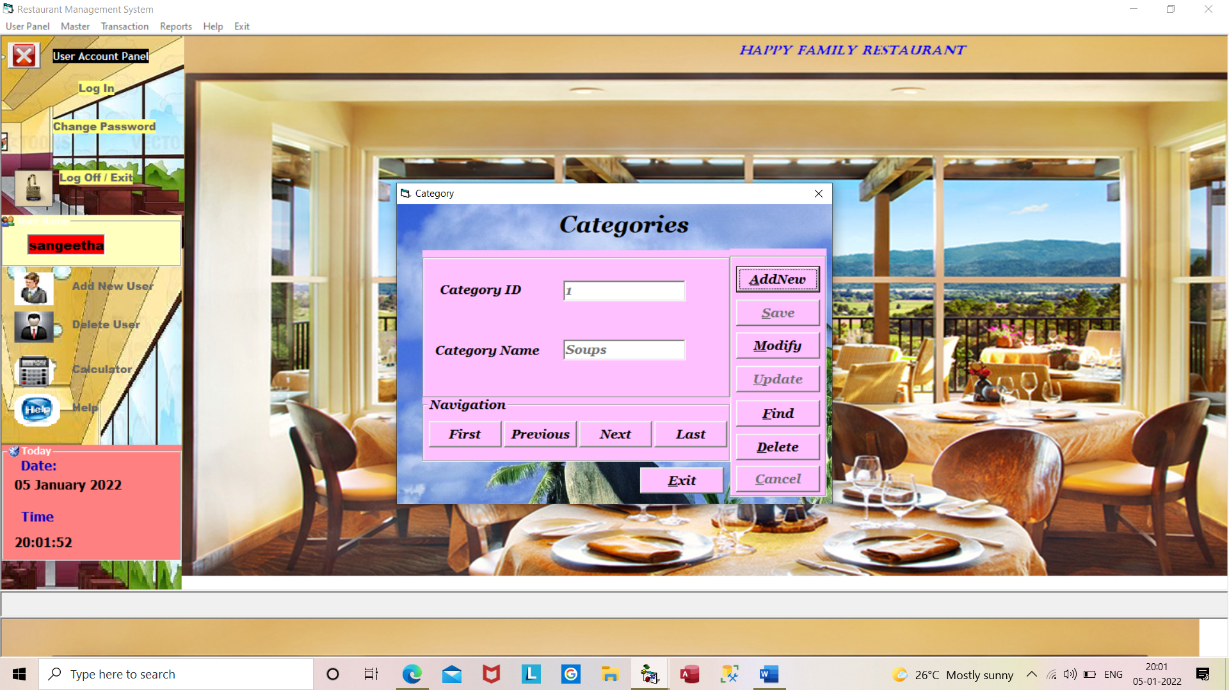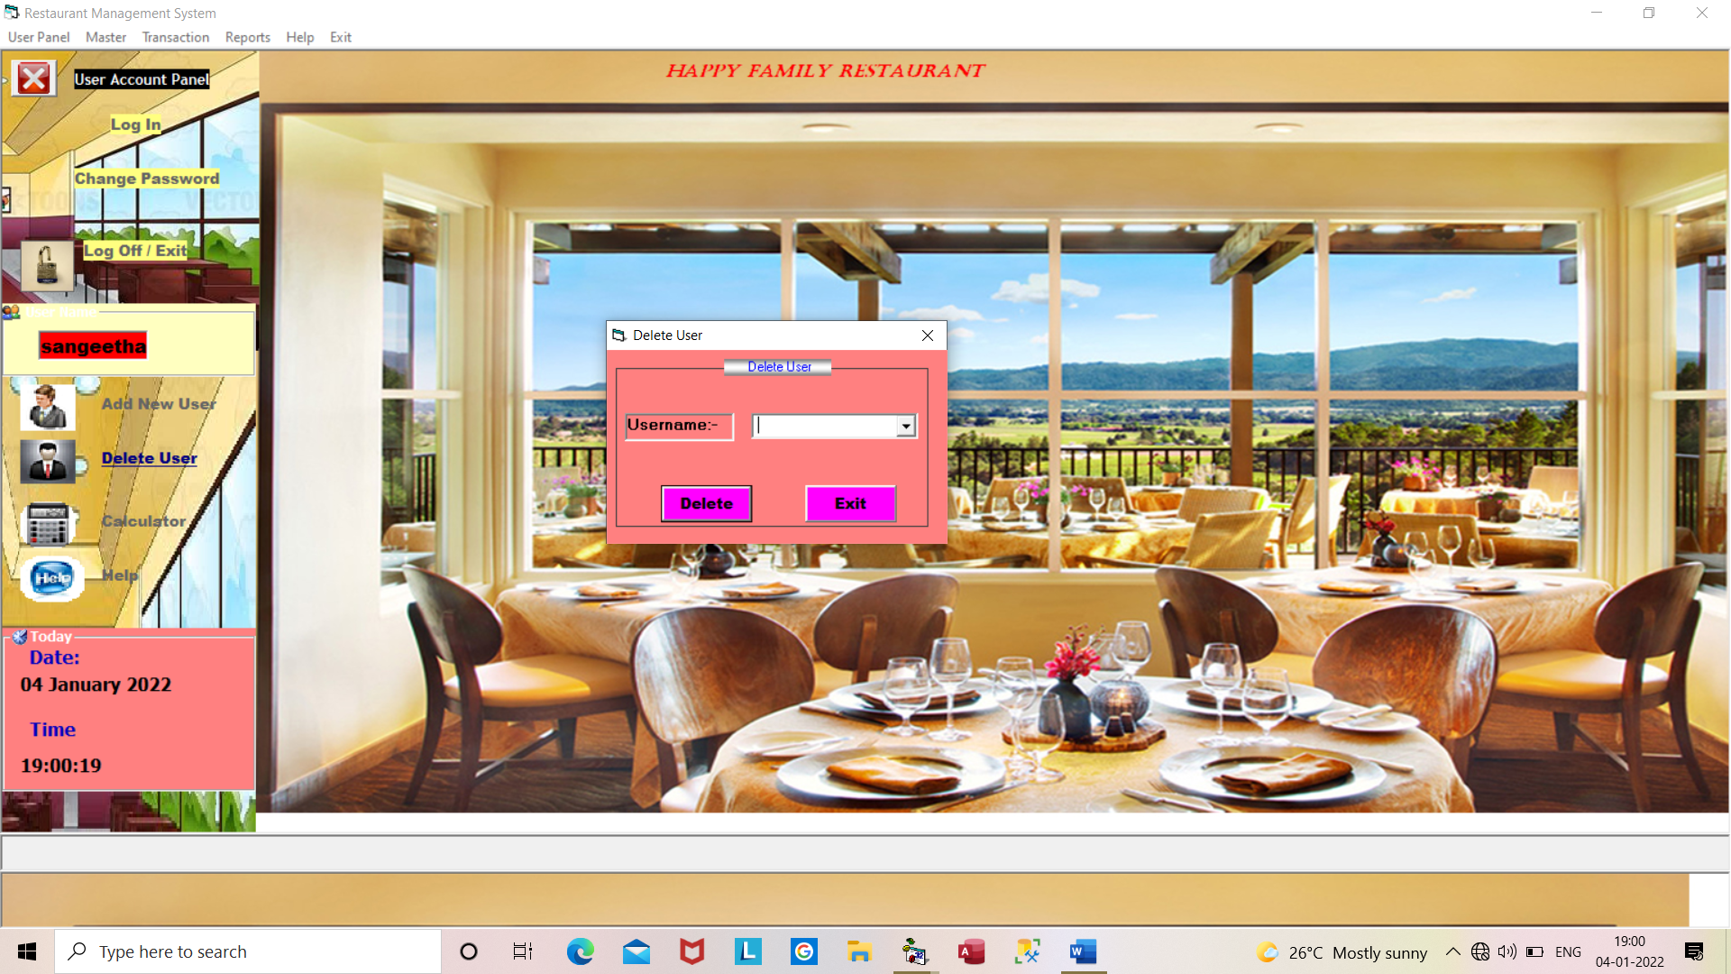

**Fig 6.6: Form to Delete User Fig 6.7:CategoriesForm**

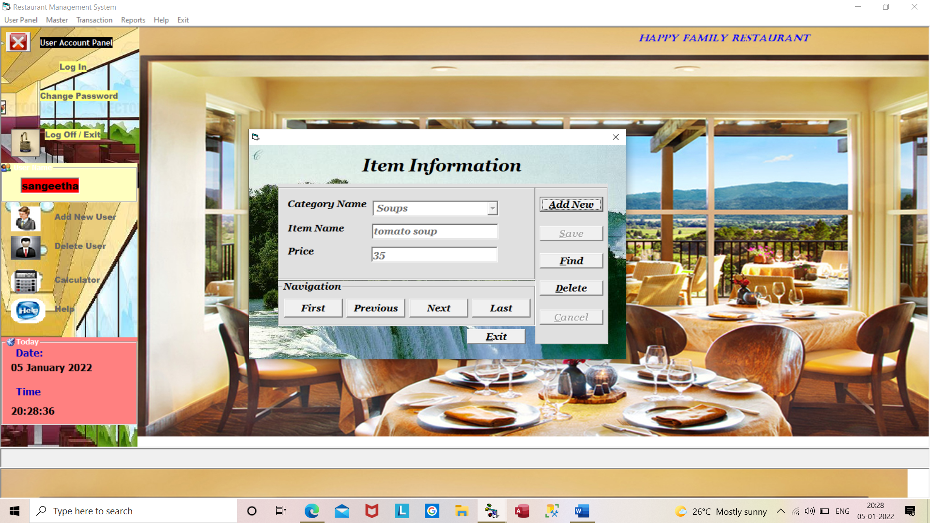

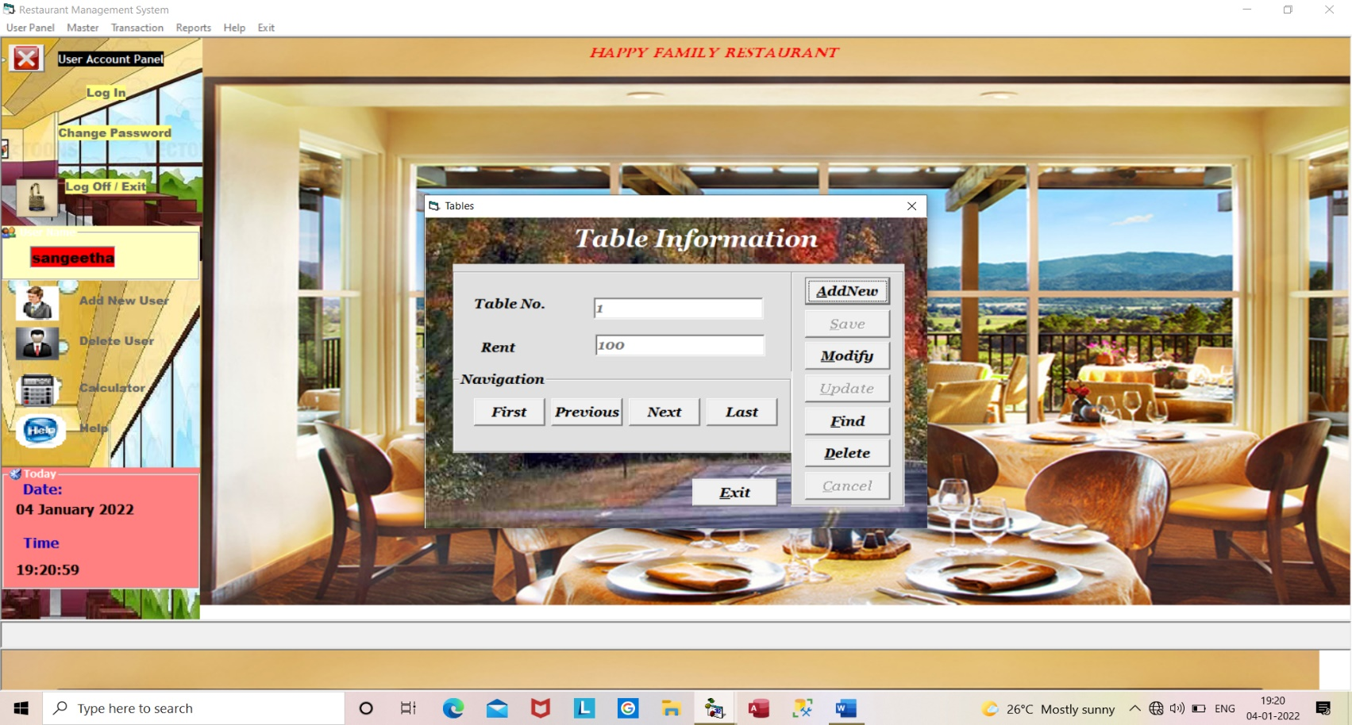

**Fig 6.8: Item Information Form Fig 6.9:Table Information Form**

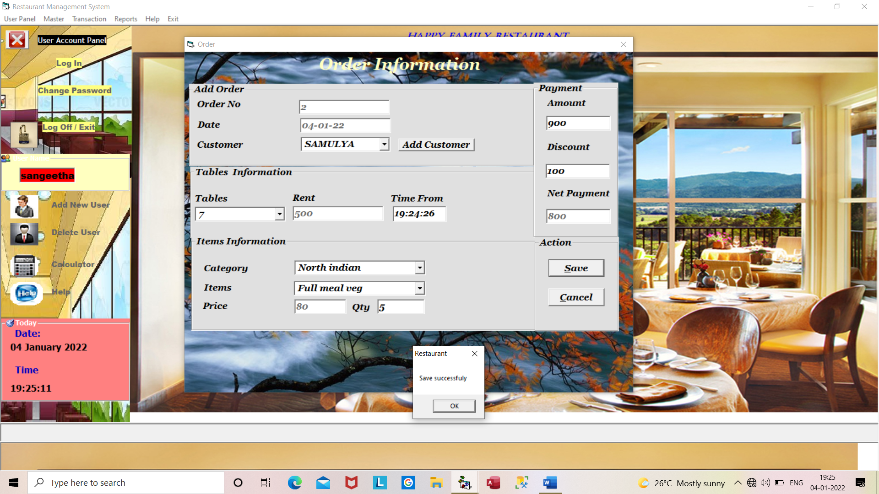

**Fig 6.10: Order Information Form**

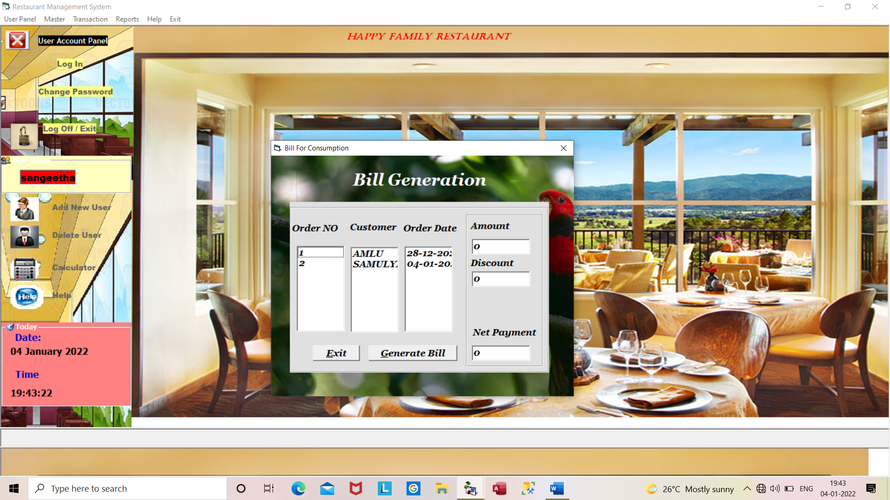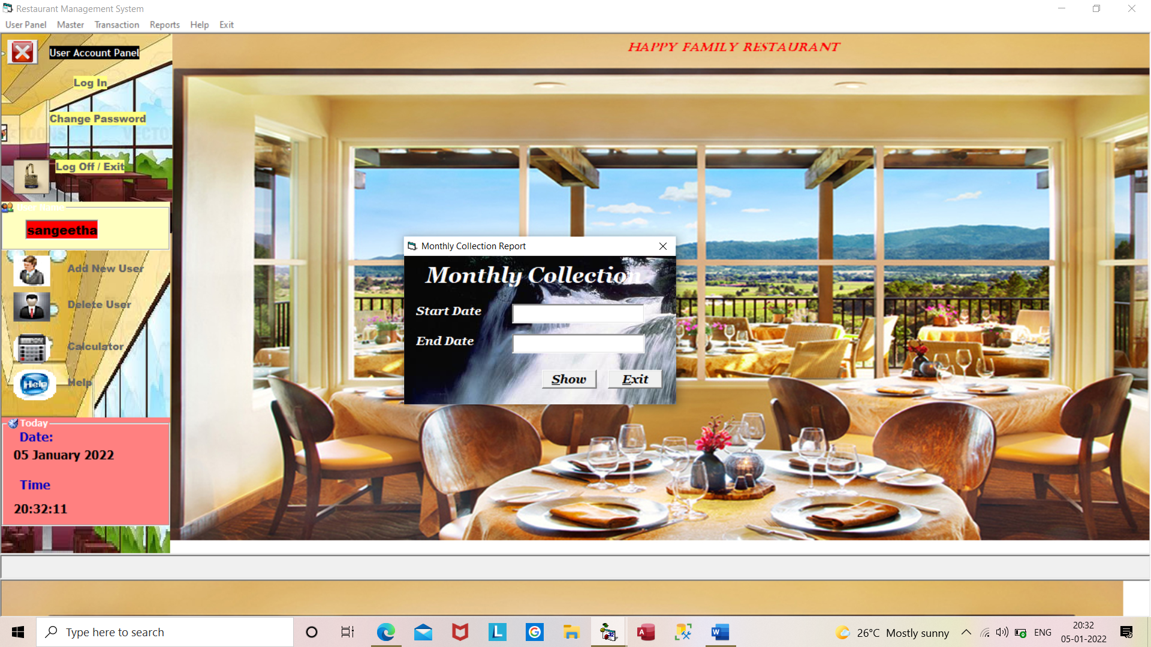

**Fig 6.11: Bill Generation Form Fig6.12:Monthly Collection Form**

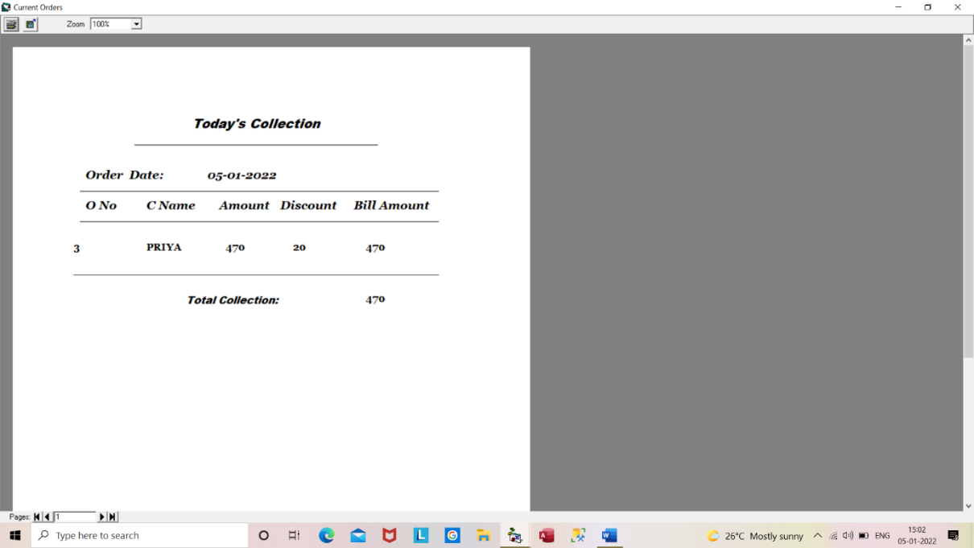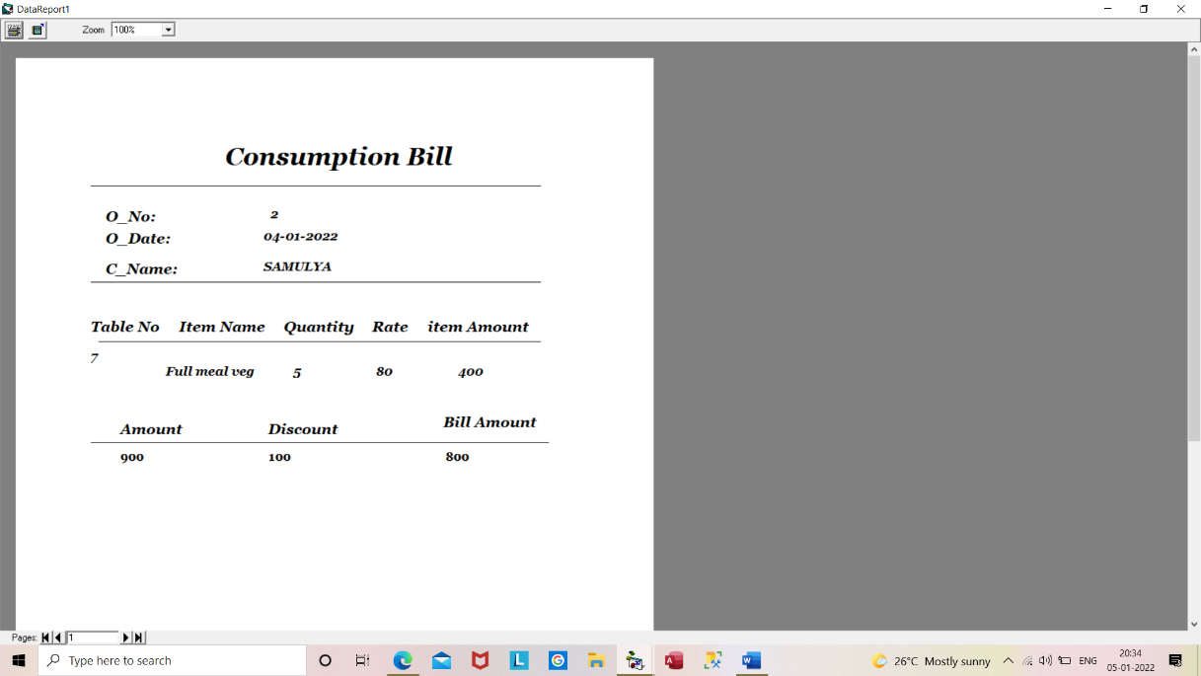

**Fig 6.13:Consumption Bill Report Fig6.14:Today’sCollectionReport**

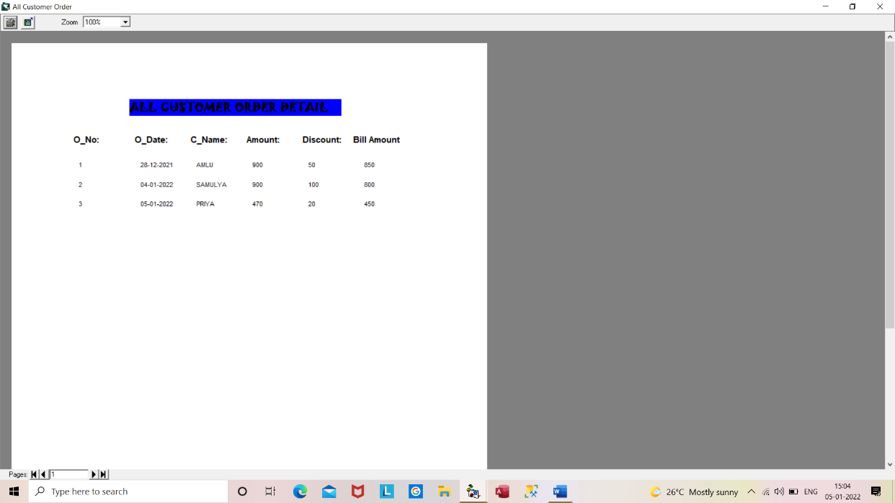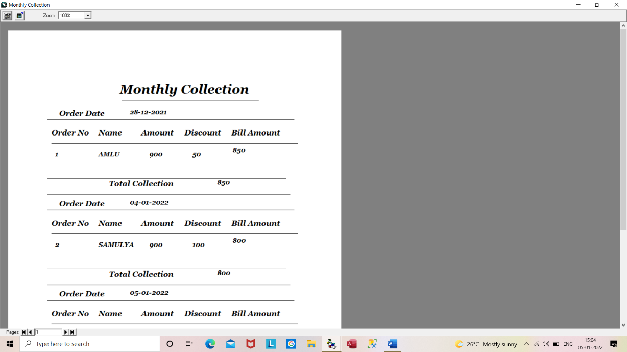

**Fig6.15: Monthly Collection Report Fig6.16: All Customer OrderReport**

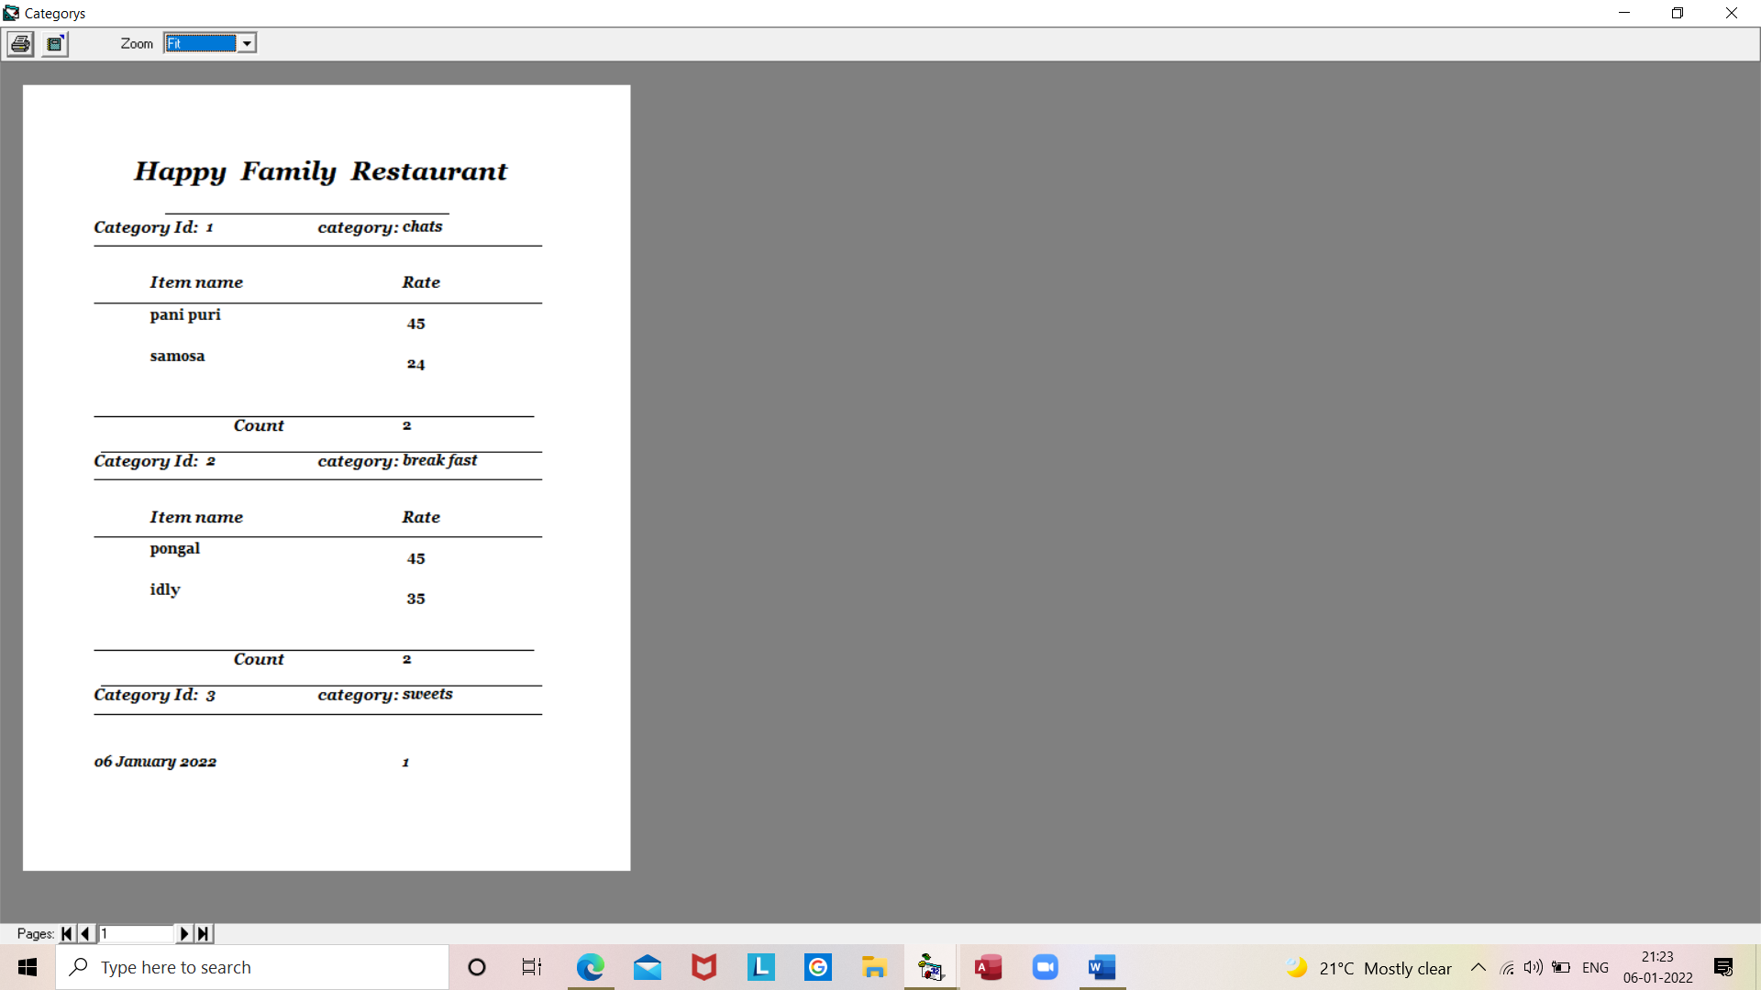

**Fig 6.17 Menu Report**

**TESTING**

**CHAPTER 7**

**TESTING**

**SYSTEM TESTING**

**TESTING**

Testing goes through the various stages, during testing the program to be tested has to be executed with a set of test cases, and ha the output of the program for the test case is evaluated to determine if the program is performing as expected. Due to its approach dynamic testing only ascertains the presence of error in the program. The exact nature of error is not usually decided by testing. Testing form is the first in determining error in the program.

Once the programs are tested individually then the system as a whole needs to be tested. During testing, the system is used experimentally to ensure that the software does not fail t.e. it will run according to its specification. The programs executed to check for any syntax or logical error. The error is corrected and test is made to determine whether the program is doing what it is supposed to do.

**Various types of testing**

**7.1 Unit testing**

Each component of the system is tested individually. The programmer does the testing. Testing is restrictive in nature i.e. programmer should try to test all individual conditions and see if the program breaks under any circumstance.

**7.2 System testing**

This is an integrated form of testing, which focuses on functionality and interface between units and team in a controlled environment does it.

**7.3 Acceptance Testing**

This is system testing done by the user of the application the only emphasis is functionally testing as the user is not aware of the technical aspect of the system. The testing is also done in a controlled environment with logging o all error based on the error found in the system, the user has to accept or reject the system.

**7.4 Module Testing**

This is an optional form of testing, which is done only for large system, which has a large number of modules.

**7.5 Security Testing**

Security testing will be done as a specialized form of testing if there is a high risk exposure in that area. If the risk exposure is not very high, then it can be done as part of the system testing. Typically, security testing would involve trying to break in to the system, trying to execute. transactions not allowed to person; to access areas on disk were the user is not allowed.

Testing is vital the success of the system. If it on this done successfully, this shows that the parts of the system are working correctly and all the goals are achieved.

**CONCLUSION**

**CHAPTER 8**

**CONCLUSION**

We were able to create a computerized system for Simple Route to maintain billing & Restaurant records. This system is able to store billing records securely and retrieve the records whenever needed easily. Data entering of customers, change of foods, menu etc are also included in this system along with the order and the billing process. Customers, restaurant records and employees are interconnected in order to maintain the accuracy of this system. This system can also be further improved adding many other features and including the other systems as well. Finally, we believe that we were able to launch an effective computerized system to the restaurant causing the restaurant to perform well in the future regarding the billing and restaurant records.

Each and every task of maintaining the restaurant activities are maintained very well and easily. All the activities are maintained efficiently

**BIBLIOGRAPHY**

**CHAPTER 9**

**BIBLIOGRAPHY**

**Books:**

**Visual Programing**

**-Padma Geetha B.G**

**-Srikanth S**

**Websites:**

[(PDF) Restaurant Management System | rehana akhter - Academia.edu](https://www.academia.edu/36675814/Restaurant_Management_System)

[SQL Server Management Studio (SSMS) (tutorialsteacher.com)](https://www.tutorialsteacher.com/sqlserver/sql-server-management-studio)

[specify provider and connection string in VB6\Connect Database - YouTube](https://www.youtube.com/watch?v=fAQkJoH829o&t=2s)

[One-to-One, One-to-Many Table Relationships in SQL Server (tech-recipes.com)](https://www.tech-recipes.com/rx/56738/one-to-one-one-to-many-table-relationships-in-sql-server/#:~:text=Relationships%20are%20defined%20on%20the%20basis%20of%20matching,table%20using%20database%20relationships.%20Consider%20the%20following%20example.)

[database - Generate table relationship diagram from existing schema (SQL Server) - Stack Overflow](https://stackoverflow.com/questions/168724/generate-table-relationship-diagram-from-existing-schema-sql-server)

[WinWorld: Microsoft Visual Basic 6.0 (winworldpc.com)](https://winworldpc.com/product/microsoft-visual-bas/60#:~:text=Microsoft%20Visual%20Basic%206.0.%20Microsoft%20Visual%20Basic.%206.0.,of%20program%20code%20to%20write%20in%20C%20)

**CODING**

**CHAPTER 10**

**CODING**

**Coding for Login Form:**

Option Explicit

Dim rec As ADODB.Recordset

Private Sub cmdExit_Click()

End

End Sub

Private Sub cmdLogin_Click()

If txtInput(0).Text = "" And txtInput(1).Text = "" Then

MsgBox "Please Enter User Name and Password"

Exit Sub

End If

If rec.RecordCount > 0 Then

rec.MoveFirst

rec.Find "User_name='" & txtInput(0).Text & "'"

If rec.EOF Then

MsgBox "Incorrect username", vbOKOnly

txtInput(0).Text = ""

txtInput(1).Text = ""

txtInput(0).SetFocus

Exit Sub

Else

If rec.Fields("password").Value <> txtInput(1).Text Then

MsgBox "Incorrect password", vbOKOnly

txtInput(0).Text = ""

txtInput(1).Text = ""

txtInput(0).SetFocus

Exit Sub

End If

End If

End If

Timer1.Enabled = True

ProgressBar1.Visible = True

Shape1.Visible = True

Shape2.Visible = True

Shape3.Visible = True

Label2.Visible = True

Label3.Visible = True

End Sub

Private Sub Form_Activate()

txtInput(0).SetFocus

End Sub

Private Sub Form_Load()

If Not OpenConnection Then

MsgBox "Error while connecting with this database"

End

End If

Set rec = New ADODB.Recordset

rec.Open "Select * from Login", cn, adOpenKeyset, adLockOptimistic

End Sub

Private Sub Timer1_Timer()

If Shape1.Visible Then

Shape2.Visible = True

Shape1.Visible = False

Shape3.Visible = False

ElseIf Shape2.Visible Then

Shape3.Visible = True

Shape2.Visible = False

Shape1.Visible = False

ElseIf Shape3.Visible Then

Shape1.Visible = True

Shape2.Visible = False

Shape3.Visible = False

End If

ProgressBar1.Value = ProgressBar1.Value + 5

Label2.Caption = "Loading"

Label3.Caption = ProgressBar1.Value & "%"

If (ProgressBar1.Value = ProgressBar1.Max) Then

Timer1.Enabled = False

mdiMain.Show

mdiMain.Label18.Caption = txtInput(0).Text

Unload Me

End If

End Sub

**Coding For Add New User Form:**

Private Sub cmdClose_Click()

Unload frmAddNewUser

End Sub

Private Sub cmdSave_Click()

If txtUsername.Text = "" Then

MsgBox "Enter UserName and Password ...", vbExclamation

txtUsername.SetFocus

Exit Sub

End If

If txtPassword.Text = "" Then

MsgBox "Enter Password ...", vbExclamation

txtPassword.SetFocus

Exit Sub

End If

If txtConfirmPassword.Text = "" Then

MsgBox "Enter confirpassword ...", vbExclamation

txtConfirmPassword.SetFocus

Exit Sub

End If

If txtPassword.Text <> txtConfirmPassword.Text Then

MsgBox "Confirm password dosenot match with new password ...", vbExclamation

txtConfirmPassword.Text = ""

txtPassword.Text = ""

txtPassword.SetFocus

Exit Sub

End If

Set rs = cn.Execute("select * from Login where User_name='" + txtUsername.Text + "' and Password='" + txtPassword.Text + "'")

If (Not rs.EOF) Then

MsgBox "Sorry!! User already exists. Try another username", vbCritical

txtPassword.Text = ""

txtConfirmPassword.Text = ""

txtUsername.Text = ""

txtUsername.SetFocus

Else

cn.Execute ("insert into Login values('" + txtUsername.Text + "','" + txtPassword.Text + "')")

MsgBox "User added sucessfully", vbInformation

txtPassword.Text = ""

txtConfirmPassword.Text = ""

txtUsername.Text = ""

txtUsername.SetFocus

frmAddNewUser.Hide

mdiMain.Show

End If

End Sub

Private Sub Form_Load()

OpenConnection

End Sub

**Coding For Delete User Form**

Private Sub cmdDeleteUser_Click()

cn.Execute ("delete from Login where User_name='" + cmbUsername.Text + "'")

MsgBox "User deleted sucessfully!!", vbInformation

cmbUsername.Text = ""

Unload frmDeleteUser

mdiMain.Show

End Sub

Private Sub cmdExit_Click()

Unload frmDeleteUser

End Sub

Private Sub Form_Load()

OpenConnection

Set rs = cn.Execute("select * from Login")

While (Not rs.EOF)

cmbUsername.AddItem rs(0)

rs.MoveNext

Wend

End Sub

**Coding For Table Form:**

Dim rec As ADODB.Recordset

Private Function clearControls()

txtInput(0).Text = ""

txtInput(1).Text = ""

End Function

Private Function EDControls(mode As Boolean)

txtInput(1).Enabled = mode

cmdAddNew.Enabled = Not mode

cmdCancel.Enabled = mode

cmdModify.Enabled = Not mode

cmdFind.Enabled = Not mode

cmdDelete.Enabled = Not mode

End Function

Private Function EDNavigate(mode As Boolean)

fraNavigator.Enabled = mode

End Function

Private Function showData()

txtInput(0).Text = rec.Fields("Table_No").Value

txtInput(1).Text = rec.Fields("Rent").Value

End Function

Private Sub cmdAddNew_Click()

EDControls True

EDNavigate False

cmdSave.Enabled = True

cmdUpdate.Enabled = False

cmdCancel.Enabled = True

clearControls

Dim t As ADODB.Recordset

Set t = New ADODB.Recordset

t.Open "select * From Tables", cn, adOpenKeyset, adLockOptimistic

If t.RecordCount > 0 Then

t.MoveLast

txtInput(0).Text = t.Fields(0).Value + 1

Else

txtInput(0).Text = 1

End If

Set t = Nothing

txtInput(1).SetFocus

End Sub

Private Sub cmdCancel_Click()

EDControls False

EDNavigate True

cmdSave.Enabled = False

cmdUpdate.Enabled = False

showData

End Sub

Private Sub cmdDelete_Click()

Dim choice As Integer

choice = MsgBox("Do you want to Delete the Record", vbYesNo + vbQuestion, "confirmation")

If choice = vbYes Then

If rec.EOF = False And rec.BOF = False Then

rec.Delete

rec.MoveNext

If rec.EOF Then rec.MoveLast

showData

End If

End If

End Sub

Private Sub cmdExit_Click()

Unload Me

End Sub

Private Sub cmdFind_Click()

Dim s As String

If rec.RecordCount > 0 Then

rec.MoveFirst

s = InputBox("Enter The table no")

If s <> "" Then

rec.Find "Table_No='" & s & "'"

If Not rec.EOF Then

Else

MsgBox "Table Not Found"

rec.MoveLast

End If

End If

showData

End If

End Sub

Private Sub cmdModify_Click()

EDControls True

EDNavigate False

cmdSave.Enabled = False

cmdUpdate.Enabled = True

txtInput(1).SetFocus

End Sub

Private Sub cmdNavigate_click(Index As Integer)

If Index = 0 Then

rec.MovePrevious

If (rec.BOF = True) Then

MsgBox "You are already at the First Record"

End If

rec.MoveFirst

ElseIf Index = 1 Then

rec.MovePrevious

If rec.BOF Then

MsgBox "You are already at the First Record"

rec.MoveFirst

End If

ElseIf Index = 2 Then

rec.MoveNext

If rec.EOF Then

MsgBox "you are already at the last record"

rec.MoveLast

End If

Else

rec.MoveNext

If (rec.EOF = True) Then

MsgBox "You are already at the last Record"

End If

rec.MoveLast

End If

showData

End Sub

Private Sub cmdSave_Click()

If txtInput(0).Text = "" Or txtInput(1).Text = "" Then

MsgBox "please provide the data"

txtInput(1).SetFocus

Exit Sub

End If

If Not IsNumeric(txtInput(1).Text) Then

MsgBox "Price must be Numeric value"

txtInput(1).Text = ""

txtInput(1).SetFocus

Exit Sub

ElseIf txtInput(1).Text < 0 Then

MsgBox "Price must be Positive value"

txtInput(1).Text = ""

txtInput(1).SetFocus

Exit Sub

End If

EDControls False

EDNavigate True

cmdSave.Enabled = False

rec.AddNew

rec.Fields("Table_No").Value = txtInput(0).Text

rec.Fields("Rent").Value = txtInput(1).Text

rec.Update

End Sub

Private Sub cmdUpdate_Click()

If txtInput(0).Text = "" Or txtInput(1).Text = "" Then

MsgBox "Please provide the data"

Exit Sub

End If

If Not IsNumeric((txtInput(1).Text) Or (txtInput(1).Text)) Then

MsgBox "Price must be Numeric value"

Exit Sub

End If

EDControls False

EDNavigate True

cmdUpdate.Enabled = False

rec.Fields("Table_No").Value = txtInput(0).Text

rec.Fields("Rent").Value = txtInput(1).Text

rec.Update

End Sub

Private Sub Form_Load()

Set rec = New ADODB.Recordset

EDControls False

cmdSave.Enabled = False

cmdUpdate.Enabled = False

txtInput(0).Enabled = False

End Sub

Private Sub Form_Activate()

CenterWindow Me

rec.Open "Select * from Tables", cn, adOpenKeyset, adLockOptimistic

If rec.RecordCount > 0 Then

rec.MoveFirst

showData

End If

End Sub

Private Sub Form_Unload(Cancel As Integer)

rec.Close

Set rec = Nothing

End Sub

**Coding For Category Form:**

Dim rec As ADODB.Recordset

Private Function clearControls()

txtInput(0).Text = ""

txtInput(1).Text = ""

End Function

Private Function EDControls(mode As Boolean)

txtInput(1).Enabled = mode

cmdAddNew.Enabled = Not mode

cmdCancel.Enabled = mode

cmdModify.Enabled = Not mode

cmdFind.Enabled = Not mode

cmdDelete.Enabled = Not mode

End Function

Private Function EDNavigate(mode As Boolean)

fraNavigator.Enabled = mode

End Function

Private Sub cmdCancel_Click()

EDControls False

EDNavigate True

cmdSave.Enabled = False

cmdUpdate.Enabled = False

showData

End Sub

Private Sub cmdDelete_Click()

Dim t As ADODB.Recordset

Set t = New ADODB.Recordset

t.Open "Select * from Item_Table where Cat_ID=" & txtInput(0).Text, cn, adOpenKeyset, adLockOptimistic

If t.RecordCount > 0 Then

MsgBox "You Can not Delete the Record because Related Records Exists in Item Table"

Exit Sub

End If

Dim choice As Integer

choice = MsgBox("Do you want to Delete the Record", vbYesNo + vbQuestion, "confirmation")

If choice = vbYes Then

If rec.EOF = False And rec.BOF = False Then

rec.Delete

rec.MoveNext

If rec.EOF Then rec.MoveLast

showData

End If

End If

Set t = Nothing

End Sub

Private Sub cmdExit_Click()

Unload Me

End Sub

Private Sub cmdFind_Click()

Dim s As String

If rec.RecordCount > 0 Then

rec.MoveFirst

s = InputBox("Enter The Category name")

If s <> "" Then

rec.Find "Cat_Name='" & s & "'"

If Not rec.EOF Then

Else

MsgBox "Record Not Found"

rec.MoveLast

End If

End If

showData

End If

End Sub

Private Sub cmdModify_Click()

EDControls True

EDNavigate False

cmdSave.Enabled = False

cmdUpdate.Enabled = True

txtInput(1).SetFocus

End Sub

Private Sub cmdNavigate_click(Index As Integer)

If Index = 0 Then

rec.MovePrevious

If (rec.BOF = True) Then

MsgBox "You are already at the First Record"

End If

rec.MoveFirst

ElseIf Index = 1 Then

rec.MovePrevious

If rec.BOF Then

MsgBox "You are already at the First Record"

rec.MoveFirst

End If

ElseIf Index = 2 Then

rec.MoveNext

If rec.EOF Then

MsgBox "you are already at the last record"

rec.MoveLast

End If

Else

rec.MoveNext

If (rec.EOF = True) Then

MsgBox "You are already at the last Record"

End If

rec.MoveLast

End If

showData

End Sub

Private Sub cmdSave_Click()

If txtInput(0).Text = "" Or txtInput(1).Text = "" Then

MsgBox "please provide the data"

Exit Sub

End If

If Not IsNumeric(txtInput(0).Text) Then

MsgBox "Price must be Numeric value"

Exit Sub

End If

EDControls False

EDNavigate True

cmdSave.Enabled = False

rec.AddNew

rec.Fields("cat_id").Value = txtInput(0).Text

rec.Fields("cat_name").Value = txtInput(1).Text

rec.Update

End Sub

Private Sub cmdUpdate_Click()

If txtInput(0).Text = "" Or txtInput(1).Text = "" Then

MsgBox "Please provide the data"

Exit Sub

End If

If Not IsNumeric(txtInput(0).Text) Then

MsgBox "Price must be Numeric value"

Exit Sub

End If

EDControls False

EDNavigate True

cmdUpdate.Enabled = False

rec.Fields("cat_id").Value = txtInput(0).Text

rec.Fields("cat_name").Value = txtInput(1).Text

rec.Update

End Sub

Private Sub Form_Load()

Set rec = New ADODB.Recordset

rec.Open "Select * from Category", cn, adOpenKeyset, adLockOptimistic

EDControls False

cmdSave.Enabled = False

cmdUpdate.Enabled = False

txtInput(0).Enabled = False

End Sub

Private Sub Form_QueryUnload(Cancel As Integer, UnloadMode As Integer)

Query

End Sub

Private Sub Form_Unload(Cancel As Integer)

rec.Close

Set rec = Nothing

End Sub

Private Function showData()

txtInput(0).Text = rec.Fields("cat_id").Value

txtInput(1).Text = rec.Fields("cat_name").Value

End Function

Private Sub cmdAddNew_Click()

EDControls True

EDNavigate False

cmdSave.Enabled = True

cmdUpdate.Enabled = False

cmdCancel.Enabled = True

clearControls

Dim t As ADODB.Recordset

Set t = New ADODB.Recordset

t.Open "select * From Category", cn, adOpenKeyset, adLockOptimistic

If t.RecordCount > 0 Then

t.MoveLast

txtInput(0).Text = t.Fields(0).Value + 1

Else

txtInput(0).Text = 1

End If

Set t = Nothing

txtInput(1).SetFocus

End Sub

Private Function loadCategory()

Dim t As ADODB.Recordset

Set t = New ADODB.Recordset

t.Open "select * from Category", cn, adOpenKeyset, adLockOptimistic

If t.RecordCount > 0 Then

While Not t.EOF

txtInput(0).Text = t.Fields("cat_id").Value

txtInput(1).Text = t.Fields("cat_name").Value

t.MoveNext

Wend

End If

Set t = Nothing

End Function

Private Sub Form_Activate()

CenterWindow Me

loadCategory

If rec.RecordCount > 0 Then

rec.MoveFirst

showData

End If

End Sub

Private Sub txtInput_KeyPress(Index As Integer, KeyAscii As Integer)

If Index = 1 Then

If Not ((KeyAscii >= 65 And KeyAscii <= 90) Or (KeyAscii >= 97 And KeyAscii <= 122) Or KeyAscii = 8 Or KeyAscii = 32) Then

KeyAscii = 0

MsgBox "Please Enter Proper Category Name"

End If

End If

End Sub

**Coding for Item Table Form**

Dim rec As ADODB.Recordset

Private Function clearControls()

txtInput(0).Text = ""

txtInput(1).Text = ""

If cboCatID.ListCount > 0 Then

cboCatID.ListIndex = 0

End If

End Function

Private Function EDControls(mode As Boolean)

txtInput(0).Enabled = mode

txtInput(1).Enabled = mode

cboCatID.Enabled = mode

cmdAddNew.Enabled = Not mode

cmdCancel.Enabled = mode

cmdFind.Enabled = Not mode

cmdDelete.Enabled = Not mode

End Function

Private Function EDNavigate(mode As Boolean)

fraNavigator.Enabled = mode

End Function

Private Function showData()

Dim i As Integer

txtInput(0).Text = rec.Fields("Item_name").Value

txtInput(1).Text = rec.Fields("rate").Value

For i = 0 To cboCatID.ListCount - 1

If rec.Fields("Cat_id").Value = cboCatID.ItemData(i) Then

cboCatID.ListIndex = i

Exit For

End If

Next

End Function

Private Sub cmdAddNew_Click()

EDControls True

EDNavigate False

cmdSave.Enabled = True

cmdCancel.Enabled = True

clearControls

txtInput(0).SetFocus

End Sub

Private Sub cmdCancel_Click()

EDControls False

EDNavigate True

cmdSave.Enabled = False

showData

End Sub

Private Sub cmdDelete_Click()

Dim choice As Integer

choice = MsgBox("Do you want to Delete the Record", vbYesNo + vbQuestion, "confirmation")

If choice = vbYes Then

If rec.EOF = False And rec.BOF = False Then

rec.Delete

rec.MoveNext

If rec.EOF Then rec.MoveLast

showData

End If

End If

End Sub

Private Sub cmdModify_Click()

EDControls True

EDNavigate False

cmdSave.Enabled = False

cmdUpdate.Enabled = True

txtInput(0).SetFocus

End Sub

Private Sub cmdNavigate_click(Index As Integer)

If Index = 0 Then

rec.MovePrevious

If (rec.BOF = True) Then

MsgBox "You are already at the First Record"

End If

rec.MoveFirst

ElseIf Index = 1 Then

rec.MovePrevious

If rec.BOF Then

MsgBox "You are already at the First Record"

rec.MoveFirst

End If

ElseIf Index = 2 Then

rec.MoveNext

If rec.EOF Then

MsgBox "you are already at the last record"

rec.MoveLast

End If

Else

rec.MoveNext

If (rec.EOF = True) Then

MsgBox "You are already at the last Record"

End If

rec.MoveLast

End If

showData

End Sub

Private Sub cmdSave_Click()

If txtInput(0).Text = "" Or txtInput(1).Text = "" Then

MsgBox "please provide the data"

Exit Sub

End If

If Not IsNumeric(txtInput(1).Text) Then

MsgBox "Price must be Numeric value"

Exit Sub

End If

EDControls False

EDNavigate True

cmdSave.Enabled = False

rec.AddNew

rec.Fields("Item_name").Value = txtInput(0).Text

rec.Fields("Rate").Value = txtInput(1).Text

rec.Fields("Cat_id").Value = cboCatID.ItemData(cboCatID.ListIndex)

rec.Update

End Sub

Private Sub Form_Activate()

CenterWindow Me

loadCategory

If rec.RecordCount > 0 Then

rec.MoveFirst

showData

End If

End Sub

Private Sub Form_Load()

Set rec = New ADODB.Recordset

rec.Open "Select * from Item_Table", cn, adOpenKeyset, adLockOptimistic

EDControls False

cmdSave.Enabled = False

End Sub

Private Sub Form_Unload(Cancel As Integer)

rec.Close

Set rec = Nothing

End Sub

Private Function loadCategory()

Dim t As ADODB.Recordset

Set t = New ADODB.Recordset

t.Open "select * from Category", cn, adOpenKeyset, adLockOptimistic

cboCatID.Clear

If t.RecordCount > 0 Then

While Not t.EOF

cboCatID.AddItem t.Fields("cat_name").Value

cboCatID.ItemData(cboCatID.NewIndex) = t.Fields("cat_id").Value

t.MoveNext

Wend

End If

Set t = Nothing

End Function

Private Sub txtInput_KeyPress(Index As Integer, KeyAscii As Integer)

If Index = 0 Then

If Not ((KeyAscii >= 65 And KeyAscii <= 90) Or (KeyAscii >= 97 And KeyAscii <= 122) Or KeyAscii = 8 Or KeyAscii = 32) Then

KeyAscii = 0

MsgBox "Please Enter Proper Item Name"

End If

ElseIf Index = 1 Then

If Not ((KeyAscii >= 48 And KeyAscii <= 57) Or (KeyAscii = 8) Or (KeyAscii = 46)) Then

KeyAscii = 0

MsgBox "Please Enter Numeric Value "

End If

End If

End Sub

**Coding For Order Form**

Dim FirstTime As Boolean

Dim rec As ADODB.Recordset

Private Sub cboCategory_click()

loadItems

txtPrice.Text = ""

End Sub

Private Sub cbocustomer_KeyPress(KeyAscii As Integer)

Call capsonly(KeyAscii)

End Sub

Private Sub cboTables_Click()

txtRent.Text = ""

Dim r As New Recordset

r.Open "select * from Tables where Table_No=" & Val(Trim(cboTables.Text)) & " ", cn, adOpenDynamic, adLockOptimistic

If r.EOF = True Then

MsgBox "There is no table "

Exit Sub

Else

txtRent.Text = r.Fields("Rent").Value

End If

End Sub

Private Sub cmdAddCustomer_Click()

Dim cname As String, r As New Recordset, cid As Integer

cname = UCase(InputBox("Enter Customer name"))

cbocustomer.AddItem cname

r.Open "select * from Customer", cn, adOpenDynamic, adLockOptimistic

If r.EOF = True Then

cid = 1

cnn.Execute "insert into Customer(C_No,Cname) values(" & cid & " ,'" & cname & "')"

Exit Sub

Else

r.MoveLast

cid = r.Fields("C_No").Value + 1

If cname = "" Then Exit Sub

cn.Execute "insert into Customer(C_No,C_name) values(" & cid & " ,'" & cname & "')"

End If

r.Close

End Sub

End Sub

Private Sub cmdSave_Click()

If Val(txtAmount.Text) <= Val(txtDiscount.Text) Then

MsgBox "Please Enter Discount less than Amount"

txtDiscount.SetFocus

Exit Sub

End If

If cbocustomer.Text = "" Then

MsgBox "Please Enter Customer Name"

Exit Sub

End If

If txtDiscount.Text = "" Then

MsgBox "Please Enter Discount"

txtDiscount.SetFocus

Exit Sub

End If

Dim rest As ADODB.Recordset

Set rest = New ADODB.Recordset

rest.Open "select * from morder", cn, adOpenKeyset, adLockOptimistic

rest.AddNew

rest.Fields("O_No").Value = txtOrderNo.Text

rest.Fields("O_Date").Value = txtOrderDate.Text

rest.Fields("C_Name").Value = cbocustomer.Text

rest.Fields("Amount").Value = txtAmount.Text

rest.Fields("Discount").Value = txtDiscount.Text

'qty.Fields("O_Table").Value = cboTables.Text

rest.Fields("BAmount").Value = Val(txtAmount.Text) - Val(txtDiscount.Text)

rest.Update

Dim qty As ADODB.Recordset

Set qty = New ADODB.Recordset

qty.Open "select * from Order_Items", cn, adOpenKeyset, adLockOptimistic

qty.AddNew

qty.Fields("O_No").Value = txtOrderNo.Text

qty.Fields("O_Date").Value = txtOrderDate.Text

qty.Fields("O_Table").Value = cboTables.Text

qty.Fields("Item_name").Value = cboItems.Text

qty.Fields("C_Name").Value = cbocustomer.Text

qty.Fields("Rate").Value = txtPrice.Text

qty.Fields("Qty").Value = txtqty.Text

qty.Fields("ItemAmount").Value = Val(txtqty.Text) * Val(txtPrice.Text)

qty.Fields("Amount").Value = txtAmount.Text

qty.Fields("Discount").Value = txtDiscount.Text

qty.Fields("BAmount").Value = Val(txtAmount.Text) - Val(txtDiscount.Text)

qty.Update

MsgBox "Save successfuly"

End Sub

If txtDiscount.Text = "" Then

MsgBox "Please Enter Discount"

txtDiscount.SetFocus

Exit Sub

End If

If Val(txtAmount.Text) <= Val(txtDiscount.Text) Then

MsgBox "Please Enter Discount less than Amount"

txtDiscount.SetFocus

Exit Sub

End If

End Sub

Public Sub capsonly(KeyAscii As Integer)

If KeyAscii >= 97 And KeyAscii <= 122 Then

KeyAscii = KeyAscii - 32

Else

KeyAscii = KeyAscii

End If

End Sub

Private Sub cmsave_MouseMove(Button As Integer, Shift As Integer, x As Single, y As Single)

txtNetPayment.Text = Val(txtAmount.Text) - Val(txtDiscount.Text)

End Sub

Private Function loadTableNo()

Dim t As ADODB.Recordset

Dim h As Integer

h = Hour(Time)

Set t = New ADODB.Recordset

t.Open "select * from Tables", cn, adOpenKeyset, adLockOptimistic

cboTables.Clear

If t.RecordCount > 0 Then

While Not t.EOFm

cboTables.AddItem t.Fields(0).Value

cboTables.ItemData(cboTables.NewIndex) = t.Fields(1).Value

t.MoveNext

Wend

End If

Set t = Nothing

cboTables.ListIndex = -1

End Function

Private Function loadCategory()

Dim t As ADODB.Recordset

Set t = New ADODB.Recordset

t.Open "select * from Category", cn, adOpenKeyset, adLockOptimistic

cbocategory.Clear

If t.RecordCount > 0 Then

While Not t.EOF

cbocategory.AddItem t.Fields("cat_name").Value

cbocategory.ItemData(cbocategory.NewIndex) = t.Fields("cat_id").Value

t.MoveNext

Wend

End If

Set t = Nothing

cbocategory.ListIndex = 0

End Function

Private Function loadItems()

Dim t As ADODB.Recordset

Set t = New ADODB.Recordset

If cbocategory.ListIndex >= 0 Then

t.Open "select * from Item_Table where Cat_Id=" & cbocategory.ItemData(cbocategory.ListIndex), cn, adOpenKeyset, adLockOptimistic

cboItems.Clear

If t.RecordCount > 0 Then

While Not t.EOF

cboItems.AddItem t.Fields(0).Value

cboItems.ItemData(cboItems.NewIndex) = t.Fields(1).Value

t.MoveNext

Wend

End If

End If

Set t = Nothing

cboItems.ListIndex = -1

End Function

Private Sub cboItems_Click()

If (cboItems.ListIndex >= 0) Then

txtPrice.Text = Val(cboItems.ItemData(cboItems.ListIndex))

Else

txtPrice.Text = ""

End If

End Sub

Private Function loadCName()

Dim t As ADODB.Recordset

Set t = New ADODB.Recordset

t.Open "select * from customer", cn, adOpenKeyset, adLockOptimistic

cbocustomer.Clear

If t.RecordCount > 0 Then

While Not t.EOF

cbocustomer.AddItem t.Fields("C_Name").Value

cbocustomer.ItemData(cbocustomer.NewIndex) = t.Fields("C_No").Value

t.MoveNext

Wend

End If

Set t = Nothing

cbocustomer.ListIndex = 0

End Function

Private Sub txtDiscount_KeyPress(KeyAscii As Integer)

If Not ((KeyAscii >= 48 And KeyAscii <= 57) Or KeyAscii = 8) Then

KeyAscii = 0

End If

End Sub

Private Sub txtDiscount_LostFocus()

txtNetPayment = Val(txtAmount.Text) - Val(txtDiscount.Text)

End Sub

Private Function clearControls()

cbocustomer.ListIndex = -1

optConsumed.Value = True

LstTables.Clear

lstStartTime.Clear

lstItems.Clear

lstquantity.Clear

cboTables.ListIndex = -1

cboTimeFrom.ListIndex = -1

cbocategory.ListIndex = -1

cboItems.ListIndex = -1

txtRent.Text = ""

txtHours.Text = ""

txtPrice.Text = ""

txtAmount.Text = ""

txtDiscount.Text = ""

txtNetPayment.Text = ""

End Function

Private Sub txtDiscount_MouseUp(Button As Integer, Shift As Integer, x As Single, y As Single)

txtNetPayment = Val(txtAmount.Text) - Val(txtDiscount.Text)

End Sub

Private Sub txtqty_KeyPress(KeyAscii As Integer)

If Not ((KeyAscii >= 48 And KeyAscii <= 57) Or KeyAscii = 8) Then

KeyAscii = 0

MsgBox "Please Enter Numerc Value"

Exit Sub

End If

End Sub

Private Sub generateOID()

Dim r As ADODB.Recordset

Set r = New ADODB.Recordset

r.Open "select * from morder", cn, adOpenKeyset, adLockOptimistic

If r.EOF = True Then

txtOrderNo.Text = 1

Exit Sub

Else

r.MoveLast

txtOrderNo.Text = r.Fields("O_No").Value + 1

End If

End Sub

Private Sub txtqty_LostFocus()

txtAmount.Text = ""

If txtqty.Text = "" Then

txtAmount.Text = Val(txtPrice.Text) * 1

Else

txtAmount.Text = Val(txtPrice.Text) * Val(txtqty.Text) + Val(txtRent.Text)

End If

End Sub

**Coding For MDI Form:**

Private Sub Command1_Click()

If Picture1.Visible = True Then

Picture1.Visible = False

mnuSideBar.Checked = False

End If

End Sub

Private Sub Image2_MouseMove(Button As Integer, Shift As Integer, x As Single, y As Single)

lblShortcut(0).ForeColor = &H80000006

lblShortcut(1).ForeColor = &H80000006

lblShortcut(2).ForeColor = &H80000006

lblShortcut(3).ForeColor = &H80000006

lblShortcut(4).ForeColor = &H80000006

lblShortcut(5).ForeColor = &H80000006

lblShortcut(6).ForeColor = &H80000006

lblShortcut(0).FontUnderline = False

lblShortcut(1).FontUnderline = False

lblShortcut(2).FontUnderline = False

lblShortcut(3).FontUnderline = False

lblShortcut(4).FontUnderline = False

lblShortcut(5).FontUnderline = False

lblShortcut(6).FontUnderline = False

End Sub

Private Sub imgUserAccount_MouseMove(Button As Integer, Shift As Integer, x As Single, y As Single)

lblShortcut(0).ForeColor = &H80000006

lblShortcut(1).ForeColor = &H80000006

lblShortcut(2).ForeColor = &H80000006

lblShortcut(3).ForeColor = &H80000006

lblShortcut(4).ForeColor = &H80000006

lblShortcut(5).ForeColor = &H80000006

lblShortcut(6).ForeColor = &H80000006

lblShortcut(0).FontUnderline = False

lblShortcut(1).FontUnderline = False

lblShortcut(2).FontUnderline = False

lblShortcut(3).FontUnderline = False

lblShortcut(4).FontUnderline = False

lblShortcut(5).FontUnderline = False

lblShortcut(6).FontUnderline = False

End Sub

Private Sub lblShortcut_Click(Index As Integer)

Select Case (Index)

Case 0:

mdiMain.Hide

frmLogin.Show

Case 1:

frmAddNewUser.Show , Me

frmDeleteUser.Hide

frmChangePassword.Hide

Case 2:

Shell "calc.exe", vbNormalFocus

Case 3:

cdlg.ShowHelp

Case 4:

frmChangePassword.Show , Me

frmAddNewUser.Hide

frmDeleteUser.Hide

Case 5:

iLogOutReply = MsgBox(UserName & ", Are You Sure You Wish To Log Out Of Your Account?", vbYesNo + vbQuestion, "Log Out?")

If iLogOutReply = vbYes Then

End

End If

Case 6:

frmDeleteUser.Show , Me

frmAddNewUser.Hide

frmChangePassword.Hide

End Select

End Sub

Private Sub lblShortcut_MouseMove(Index As Integer, Button As Integer, Shift As Integer, x As Single, y As Single)

Select Case (Index)

Case 0:

lblShortcut(0).ForeColor = &H800000

lblShortcut(1).ForeColor = &H80000006

lblShortcut(2).ForeColor = &H80000006

lblShortcut(3).ForeColor = &H80000006

lblShortcut(4).ForeColor = &H80000006

lblShortcut(5).ForeColor = &H80000006

lblShortcut(6).ForeColor = &H80000006

lblShortcut(0).FontUnderline = True

lblShortcut(1).FontUnderline = False

lblShortcut(2).FontUnderline = False

lblShortcut(3).FontUnderline = False

lblShortcut(4).FontUnderline = False

lblShortcut(5).FontUnderline = False

lblShortcut(6).FontUnderline = False

Case 1:

lblShortcut(0).ForeColor = &H80000006

lblShortcut(1).ForeColor = &H800000

lblShortcut(2).ForeColor = &H80000006

lblShortcut(3).ForeColor = &H80000006

lblShortcut(4).ForeColor = &H80000006

lblShortcut(5).ForeColor = &H80000006

lblShortcut(6).ForeColor = &H80000006

lblShortcut(0).FontUnderline = False

lblShortcut(1).FontUnderline = True

lblShortcut(2).FontUnderline = False

lblShortcut(3).FontUnderline = False

lblShortcut(4).FontUnderline = False

lblShortcut(5).FontUnderline = False

lblShortcut(6).FontUnderline = False

Case 2:

lblShortcut(0).ForeColor = &H80000006

lblShortcut(1).ForeColor = &H80000006

lblShortcut(2).ForeColor = &H800000

lblShortcut(3).ForeColor = &H80000006

lblShortcut(4).ForeColor = &H80000006

lblShortcut(5).ForeColor = &H80000006

lblShortcut(6).ForeColor = &H80000006

lblShortcut(0).FontUnderline = False

lblShortcut(1).FontUnderline = False

lblShortcut(2).FontUnderline = True

lblShortcut(3).FontUnderline = False

lblShortcut(4).FontUnderline = False

lblShortcut(5).FontUnderline = False

lblShortcut(6).FontUnderline = False

Case 3:

lblShortcut(0).ForeColor = &H80000006

lblShortcut(1).ForeColor = &H80000006

lblShortcut(2).ForeColor = &H80000006

lblShortcut(3).ForeColor = &H800000

lblShortcut(4).ForeColor = &H80000006

lblShortcut(5).ForeColor = &H80000006

lblShortcut(6).ForeColor = &H80000006

lblShortcut(0).FontUnderline = False

lblShortcut(1).FontUnderline = False

lblShortcut(2).FontUnderline = False

lblShortcut(3).FontUnderline = True

lblShortcut(4).FontUnderline = False

lblShortcut(5).FontUnderline = False

lblShortcut(6).FontUnderline = False

Case 4:

lblShortcut(0).ForeColor = &H80000006

lblShortcut(1).ForeColor = &H80000006

lblShortcut(2).ForeColor = &H80000006

lblShortcut(3).ForeColor = &H80000006

lblShortcut(4).ForeColor = &H800000

lblShortcut(5).ForeColor = &H80000006

lblShortcut(6).ForeColor = &H80000006

lblShortcut(0).FontUnderline = False

lblShortcut(1).FontUnderline = False

lblShortcut(2).FontUnderline = False

lblShortcut(3).FontUnderline = False

lblShortcut(4).FontUnderline = True

lblShortcut(5).FontUnderline = False

lblShortcut(6).FontUnderline = False

Case 5:

lblShortcut(0).ForeColor = &H80000006

lblShortcut(1).ForeColor = &H80000006

lblShortcut(2).ForeColor = &H80000006

lblShortcut(3).ForeColor = &H80000006

lblShortcut(4).ForeColor = &H80000006

lblShortcut(5).ForeColor = &H800000

lblShortcut(6).ForeColor = &H80000006

lblShortcut(0).FontUnderline = False

lblShortcut(1).FontUnderline = False

lblShortcut(2).FontUnderline = False

lblShortcut(3).FontUnderline = False

lblShortcut(4).FontUnderline = False

lblShortcut(5).FontUnderline = True

lblShortcut(6).FontUnderline = False

Case 6:

lblShortcut(0).ForeColor = &H80000006

lblShortcut(1).ForeColor = &H80000006

lblShortcut(2).ForeColor = &H80000006

lblShortcut(3).ForeColor = &H80000006

lblShortcut(4).ForeColor = &H80000006

lblShortcut(5).ForeColor = &H80000006

lblShortcut(6).ForeColor = &H800000

lblShortcut(0).FontUnderline = False

lblShortcut(1).FontUnderline = False

lblShortcut(2).FontUnderline = False

lblShortcut(3).FontUnderline = False

lblShortcut(4).FontUnderline = False

lblShortcut(5).FontUnderline = False

lblShortcut(6).FontUnderline = True

End Select

End Sub

Private Sub MDIForm_Load()

Label2.Caption = Format(Date, "long date")

frmLogin.Show vbModel

End Sub

Private Sub MDIForm_QueryUnload(Cancel As Integer, UnloadMode As Integer)

Dim re As Variant

re = MsgBox("Do You Want Exit", vbYesNo)

If re = vbYes Then

End

Else

Cancel = 1

End If

End Sub

Private Sub mnuAbout_Click()

frmAbout.Show , Me

End Sub

Private Sub mnuAllCustomerOrder_Click()

rptAllCustomerOrder.Show

End Sub

Private Sub mnuCollection_Click()

If DataEnvironment1.rscmdTCollection_Grouping.State Then

DataEnvironment1.rscmdTCollection_Grouping.Close

End If

DataEnvironment1.cmdTCollection_Grouping Format(Date, "DD-MM-YY")

DRTCollection.Show

End Sub

Private Sub mnuConsumption_Click()

frmCBill.Show

End Sub

Private Sub mnuExit_Click()

If MsgBox("Are You Sure Exit System ?", vbYesNo + vbInformation, "Warning") = vbYes Then

End

Unload frmSYSTRAYICON

End If

End Sub

Private Sub mnuHomeDelivery_Click()

frmHDBill.Show

End Sub

Private Sub mnuMasterAdvanceBooking_Click()

frmAdvancedBooking.Show

End Sub

Private Sub mnuMasterCategory_Click()

frmCategory.Show

End Sub

Private Sub mnuMasterItemTable_Click()

frmItemTable.Show

End Sub

Private Sub mnuMasterOrder_Click()

frmOrder.Show

End Sub

Private Sub mnuMasterTables_Click()

frmTables.Show

End Sub

Private Sub mnuMonthlyCollection_Click()

frmMCollection.Show

End Sub

Private Sub mnuReportMenu_Click()

DRPMenu.Show

End Sub

Private Sub mnuSideBar_Click()

If Picture1.Visible = True Then

Picture1.Visible = False

mnuSideBar.Checked = False

ElseIf Picture1.Visible = False Then

Picture1.Visible = True

mnuSideBar.Checked = True

End If

End Sub

Private Sub mnuViewHelp_Click()

cdlg.ShowHelp

End Sub

Private Sub Timer1_Timer()

Label1.Caption = DateTime.Time

End Sub

**Code For Module(Database Connection Module):**

Global rs As ADODB.Recordset

Public cnn As New Connection

Global cn As ADODB.Connection

Public cno As Long

Public loadOno As Long

Public LoadTime As Boolean

Public Function CenterWindow(frm As Form)

' frm.Left = (mdiMain.ScaleWidth - frm.Width) / 2

'frm.Top = (mdiMain.ScaleHeight - frm.Height) / 2

End Function

Public Function OpenConnection() As Boolean

On Error GoTo HandleError

Set cn = New ADODB.Connection

cn.Provider = "SQLOLEDB.1;Integrated Security=SSPI;Persist Security Info=False;Initial Catalog=RESTAURANT DATABASE;Data Source=DCRUZZ\SQLEXPRESS"

cn.Open

OpenConnection = True

Exit Function

HandleError:

OpenConnection = False

End Function

Public Function CloseConnection()

cn.Close

Set cn = Nothing

End Function

Public Function Query()

Select Case UnloadMode

Case vbFormCode

Case vbFormControlMenu

Case vbFormMDIForm

MsgBox "First close the form"

Cancel = True

Case vbAppTaskManager

MsgBox "First close the application then shut Down"

Cancel = True

Case vbAppWindows

MsgBox "First close the Application"

Cancel = True

End Select

End Function